EXPLORING YOUR CHOSEN CAREER LEVEL TWO


Learner Name: Sebastian Archer
Campus: Crosskeys
School:
Full Time Course: ICT Level 2
Tutor: Richard Hayter

Learner Declaration
I confirm that the evidence submitted for assessment is my own work and has not been completed by anyone else. I am aware of the penalties for unfair practice.
Learner Signature: Date:
IQA Declaration
The work contained in this booklet has been part of the Coleg Gwent IQA process and has met all the stated criteria and outcomes
IQA Signature: Date:
Introduction
This booklet is for students on Level 2 Vocational Programmes. This module is called ‘EXPLORING YOUR CHOSEN CAREER’ and will develop the 7 employability skills. There are 3 booklets available. The assessment criteria for the tasks will be aimed at students who have a literacy/numeracy profile of L1 Literacy/Numeracy E/D GCSE maths and English
Before any sections of the booklet are started, teaching and learning on the skills will be covered.
Contents
Learning Outcomes 3
Assessment Criteria 3
Purpose 6
Key of Employability Skills 6
Section One - One Page Profile (AC 1.1) 7
Section Two– The Difference between Hard and Soft Skills? 8
Section Three – Planning your Career (AC 2.1, 2.2, 2.3, 2.4) 9
Section Four - Work placements/Skills Competitions/Community Activity (AC 3.1, 3.2) 10
Section Five – Your Digital Profile and CV (AC 4.1, 4.2) 12
Section Six – Soft Skills and Interviews (AC 5.1, 5.2, 5.3, 5.4) 13
Section Seven – Soft Skills of an Entrepreneur (AC 6.1, 6.2, 6.3, 6.4, 6.5, 10.1) 17
Section Eight – Current Opportunities for an Entrepreneur (AC 7.1, 7.2) 23
Section Ten - Time Management (AC 9.1, 9.2) 24
Section Eleven - Produce a Digital Communication on the Importance of the Soft Skills (AC 10.1, 10.2) 27
Section Twelve – Evaluation (AC 12.1) 28

Learning Outcomes | Assessment Criteria
The learner will: | The learner can:
- Complete a One Page Profile | - Complete a One Page Profile
- Create a career plan. | - Describe goals and values for this career.  - Describe preferences for this career.  - Describe the options available.  - Explain the steps needed to take to achieve your goal.
- Participate in an activity of choice | - Complete 15 hours of participation in one of the following activities :  - Work placements  - Skills Competitions  - Community Activity  3.2 Complete a log of activities  3.3 Produce a reflection on the activity
- Produce a digital profile. | - Explain the importance of your digital profile  - Produce a Digital CV
- Develop soft skills and interview skills. | - Describe what soft skills are required within the sector.  - Take part in an online mock interview  - Take part in a mock interview using the STAR method.  - Describe performance afterwards.
- Gaining entrepreneur skills and developments. | - Complete a survey to identify entrepreneurial skills.  - Describe current skills and behaviours  - Describe skills gaps and behaviours to develop to be an entrepreneur  - Describe examples of how these could be developed.
- Review the Sector | - Describe current news stories within the chosen sector  - Describe primary and secondary research sources
- Innovative Proposal | - Express an entrepreneurial solution within the chosen sector.  - Deliver a pitch/presentation  - Create one of the following:  - Information Leaflet  - Guide  - Poster
- Demonstrate how skills can assist your financial planning | - Predict time taken to make a specified journey  - Predict the costs associated with the fares
- Produce a digital communication on the importance of the soft skills | 10.1 Produce a digital communication to communicate to others ‘Why soft skills are important in today’s workplace’  10.2 Explain the importance of skills within the workplace
- Identify Welsh Language Skills and abilities | 11.1 Describe current skills by completing tasks to identify one’s own skills and abilities within the Welsh language
- Evaluate performance | 12.1 Describe the hard and soft skills developed

Assessment Guidance
AC 2.4 Action Plan
AC 3.1 Minimum of 20 hours
AC 3.2 Minimum 350 words
AC4.1 Digital CV
AC5.3 Video Clip
AC5.3 10 minutes per student
AC6.1 Enterprise Catalyst Test PDF
AC7.1 Minimum of 3 sources of information
AC 7.1 Minimum of 4 issues
AC8.1 Minimum of 350 words
AC8.2At least one - Information Leaflet, Guide or Poster
AC8.3 No more than 10 minutes
AC10.1 Digital Communication

Purpose
When selecting a career path, it’s important to conduct extensive research to determine which type of job is the best choice for you. Performing career research can help you weigh all of the factors and options to make an informed decision. When you are researching a specific career, take a look at the requirements, job duties and work environment to ensure this is compatible with your personality and soft skills. This qualification will provide you with an opportunity to explore the importance of the soft skills needed in different roles within your chosen sector. It will allow you to develop your Literacy, Numeracy, Planning and Organisation, Critical Thinking & Problem Solving, Digital Literacy, Innovation and Creativity and Personal Effectiveness to enable you to understand what soft skills it takes to be successful in your chosen career pathway.

Key of Employability Skills
The symbols below will be shown against each section to highlight what skills are being developed and assessed.
Literacy
L

Numeracy
N

Planning and Organisation
PO

Critical Thinking and Problem Solving
CTPS

Digital Literacy
DL

Innovation and Creativity
IC

Personal Effectiveness
PE
Section One - One Page Profile (AC 1.1)
L

How people would describe me…
People would describe me as a hardworking individual who
What’s important to me…

How to get the best out of me…

Section Two– The Difference between Hard and Soft Skills?
Hard skills are teachable abilities or skill sets that are easy to quantify. Typically, you'll learn hard skills in the classroom, through books or other training materials, or on the job.
Soft skills, on the other hand, are subjective skills that are much harder to quantify. Unlike hard skills, it's hard to point to specific evidence that you possess a soft skill. If an employer is looking for someone with a certain hard skill, you can use your qualification to demonstrate that you have that skill. But how can you show that you have a work ethic or any other soft skill? Just saying you have the skill isn't very meaningful. Instead, with this — and any other soft skills — your best bet is to demonstrate that you possess this quality by sharing examples of times when you used it. Soft skills drive career advancement and make people successful. Soft skills are flexible and can serve you well in numerous occupations. Though it takes more effort and creativity to properly demonstrate these abilities, they're valuable to almost any job that you might pursue.
For most jobs, technical skills alone are not enough to be truly effective, all careers require at least some soft skills to make the hard skills valuable. Soft skills are more challenging to develop, since they have little to do with knowledge or expertise, but are closely linked with a person’s character. It takes conscious effort, ongoing practice, and a commitment to self-development to improve your soft skills. Hard skills may look impressive on your CV, but the soft skills are what will set you apart from the many candidates who have similar expertise to you.

Section Three – Planning your Career (AC 2.1, 2.2, 2.3, 2.4)
CTPS
PE
PO

A career path is composed of a sequence of jobs that make up your career plan. Career paths and career plans may sound like the same thing, but they’re not. A career plan includes short-term or long-term goals leading to an ideal career, while a career path specifically includes the jobs that step an individual towards his or her goals and objectives.
Career plans can help you make decisions about what courses to take, and identify the soft skills needed, research, and work experience you will need to get to where you want.
Activity One – Create a career plan
Step 1) Identify your goals and values
Your goals and values are what’s important to you as a person. Some of my goals are to work hard in life, get a high salary job, gain new skills, become an expert in IT, and improve my overall intelligence.
Step 2) Work out your preferences
Your preferences are the things you like to do, as well as the things you prefer not to do. I prefer to use computers more than anything, I just feel more comfortable sitting in front of a keyboard. I am interested in working with networking and servers.
Step 3) Consider the options
Network Engineer
Web Designer
IT Consultant
Platform Engineer
Database Administrator
System Analyst
Data Centre Technician
Hardware Engineer

Step 4) Write down the Steps you need to take to achieve your goal
Now you’ve got a shortlist of jobs or careers you think will suit you, you need to have a strategy for finding the type of job you want.
For example, you might need to:
- do further study or training
- get experience, for example by volunteering
Once you’ve written down all the steps, put them in order. This is your action plan.
You will then need to review your plan as you learn new skills and find out things about yourself that you didn’t know before.

Section Four - Work placements/Skills Competitions/Community Activity (AC 3.1, 3.2)
L
PO
DL

Choose one of the Activities
Activity 1
A) Research organisations suitable for work experience and make arrangements for a placement.
Attach evidence of your research within the file, within this you need to demonstrate how you think this activity fits with your goals and values.
B) Take part in a placement for at least 20hrs within the select industry. You will need to create and complete a log of work based activities that include periodic self-assessment of performance. Consider the following when recording your activities on placement.
- What activities have you taken part in?
- What soft and hard skills have you used/developed?
- Feedback you may have received
- Photographic Evidence, this could include You Tube videos, photographs, videos, written statements, community feedback sheets or any other evidence of the event taking place.

C) Write a reflection of at least 350 words to evaluate if the placement has changed or reinforced any of your goals, values or preferences in your Career Plan.
Or
Activity Two
A) Participate in Skills Competition in the college, which will hopefully lead to a place in Skills Completion Wales. Skills Competition Wales consists of a series of local skills competitions, aligned to WorldSkills competitions and the needs of the Welsh economy, funded by the Welsh Government and run by a dedicated network of colleges, work-based learning providers and employer-led organisations.
https://www.inspiringskills.wales/skills-competition-wales
Research what is involved in participating in the Skills Competition and attach evidence how you think this activity fits with your goals and values.

B) Prepare and participating in a Skills Competition for at least 20hrs. You will need to create and complete a log of activities that include periodic self-assessment of performance. Consider the following when recording your activities on placement.
• What activities have you taken part in?
• What soft and hard skills have you used/developed?
• Feedback you may have received
• Photographic Evidence, this could include You Tube videos, photographs, videos, written statements, community feedback sheets or any other evidence of the event taking place.
C) Write a reflection of at least 350 words to evaluate if the Skills Competition has changed or reinforced any of your goals, values or preferences in your Career Plan.
Or
Activity Three
A) Research community activities suitable for developing your soft skills that will enhance/improve the local community and make arrangements to undertake the activity.
Attach evidence of your research within the file, within this you need to demonstrate how you think this activity fits with your goals and values.
B) Prepare and participate in the community activity for at least 20hrs within the select industry. You will need to create and complete a log of work based activities that include periodic self-assessment of performance. Consider the following when recording your activities on placement.
- What activities have you taken part in?
- What soft and hard skills have you used/developed?
- Feedback you may have received
- Photographic Evidence, this could include You Tube videos, photographs, videos, written statements, community feedback sheets or any other evidence of the event taking place.

C) Write a reflection of at least 350 words to evaluate if the community activity has changed or reinforced any of your goals, values or preferences in your Career Plan.

Section Five – Your Digital Profile and CV (AC 4.1, 4.2)
L
DL
PE
IC

Your On-line Profile and the impact it may have on potential employment
Increasingly, networking sites are used as tools by recruiters and hiring managers to seek out sources of talent. Lots of employers have had hired a candidate through social media.
A growing number of employers say that they will search for your social media profiles during the interview process. What you post and how you behave on these sites can create a first impression of the sort of person you might be.
Activity One – What are the top three things employers look for on social profiles?

- Education

- Work Experience

- Interests

Provide a brief explanation of why you think these are the top three things.
Activity Two – What are the top three things that put employers off a candidate, when they look on social profiles?
- Education is a vital asset in a job, it shows your former experience. It’s important for your employer to know what sort of work you studied in school, college or university.

2)

3)
Provide a brief explanation of why you think these are the top three things.

Activity Three - Create a LinkedIn account. Cut and paste the link to it below.

www.linkedin.com/in/sebastian-archer

When writing your soft skills don't simply list them off without providing some measure of proof to back up your statements. Anyone can say that they have strong communication skills. Demonstrate yours by highlighting projects that required you communicate effectively with a diverse group of people. With soft skills, it's more important to show than it is to tell. Include measurable details wherever possible.

Section Six – Soft Skills and Interviews (AC 5.1, 5.2, 5.3, 5.4)
PE
PO

The interview will be one opportunity that a future employer will have to identify if someone who looks good on paper will be good in person. Soft skills make all the difference. Soft skills are the personal qualities that make people easy to work with. Despite their fuzzy name, they’re critical for job performance and cultural fit. Your soft skills can make the difference between a lacklustre interview and one that lands you the job. Make sure you take the time to identify your strengths in these areas so you can shine a bright spotlight on the soft skills that make you stand out the most.
Activity One - Write down the top soft skills that you think employers would look for:
Communication
Teaching
Hardworking
Time Management

Activity Two - Write down 3 questions you think an employer may ask to identify if you possess these soft skills
- What would you do if another employee told you that someone had been talking about you behind you back?

- Could you show me some examples of this?

- Are you able to prove yourself?

Activity Three - Take part this on-line mock interview
https://www.myworldofwork.co.uk/myinterviewtool
Cut and paste your short feedback here and print and save your detailed feedback.
Activity Four – Conduct a Mock Interview
Work as team (consisting of 3-4 members), to conduct a mock interview. The interview needs to be recorded. You may feel slightly nervous or embarrassed about seeing yourself on video (everyone does, you're in good company), but it's worth getting over this shyness as it can be a powerful way of improving your interview performance and gaining experience of how you demonstrate the soft skills you have.
Using the answers from Task 1 conduct an interview. There should be at least 2 people carrying out the interview and 1 person being interviewed, lasting about 10 minutes each. Rotate the roles so that each person in the team has played at each role at least once.
When answering the questions try to be concise and speak for no longer than a few minutes on each one. For the "Tell me about a time when…" questions, you may want to use the STAR acronym to structure your answer Here's an example:
S – Situation – describe the problem you encountered
T – Task – what was required of you
A – Activity – what you did to solve the problem
R – Result – how brilliantly the situation turned out.
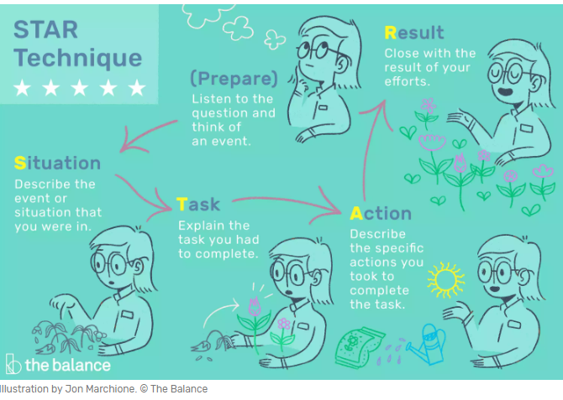

Here’s a quick example:
•I had to give an important presentation to a client at work. (Situation)
•We had to tell them about a new product – and hope they’d order some. (Task)
•I researched the product thoroughly. I talked to our design team and found what the most important features to highlight were. I put together a presentation using Powerpoint. Then I practised this in front of my team and asked them for feedback. (Actions)
•In the end, I impressed our clients. I was able to answer all their questions. They put in a big order as a result. Plus, I was able to work with the same client on future pitches. (Result)

Activity Five – Review your Performance
Review your performance. Don't do this immediately: take a break, return to the footage after around 10 minutes and watch it twice. The first time, pause between answers and make notes, answering the following questions:
Things to Review | Notes
• How fully did you answer the question?

• How convincing was your answer?

• Is there anything you would change if you were asked it again?

• How long was your answer? Could it be more concise?

• How was your body language? Did it match your words? Did you fidget?
• Are there any words that you repeat excessively? Most people have an "um" or an "actually" that they over use when they are nervous.

• Where did your eyes go? Were you maintaining eye contact with the camera?

• How was the pace of your answer?

The second time, go back and watch through from beginning to end again, without pausing. How would you rate yourself overall? If there were three things you would change, what would they
Rating | What would you change?

Section Seven – Soft Skills of an Entrepreneur (AC 6.1, 6.2, 6.3, 6.4, 6.5, 10.1)
IC
CTPS
PO
PE

As an entrepreneur, the development of soft skills can go a long way toward helping you reach success. You need to unlock your softs kills and foster them. If you don’t evolve with the world around you, you will limit your ability to be successful and entrepreneurial thinking. Entrepreneurs are opportunity-driven. Opportunity comes from changes in the environment, and one central characteristic of entrepreneurs is that they excel at seeing patterns of change. It is the entrepreneur's drive to acquire resources in order to exploit opportunities that creates the high correlation between entrepreneurship and economic growth.
Activity – Enterprise Survey
Take the Enterprise Catalyst test to identify how enterprising you are. Download your PDF report and save it as part of this module
https://www.enterprisecatalyst.co.uk/
Activity One - Identify skills and qualities that are required to be an entrepreneur.
Skills Required | Qualities Required

Activity Two – Identify the skills and behaviours you have of an entrepreneur
Current Enterprise skills | Current Enterprise Behaviours
Activity Three – Identify the skills and behaviours you need to develop to be an entrepreneur
Enterprise skills to be developed | Enterprise Behaviours to be developed

Activity Four - Give five examples of how these could develop?
1.
2.
3.
4.
5.

Activity Five/ Gweithgaredd Pump - Will having Welsh speaking skills help you to be more Entrepreneurial? A fydd sgiliau siarad Cymraeg yn eich helpu i fod yn fwy entrepreneuraidd?
A oes unrhyw fanteision i siarad Cymraeg os ydych yn dod yn entrepreneur?  Rhestrwch y rhain isod. | Are there any advantages to speaking Welsh if becoming an entrepreneur?  List these below.

A oes unrhyw fanteision o fod yn ddwyieithog os ydych yn dod yn entrepreneur?  Rhestrwch nhw isod. | Are there any advantages of being bilingual if becoming an entrepreneur?  List them below.

Edrychwch ar y rhestr o ddiwydiannau. Pa ystod o sgiliau iaith allai fod yn ddefnyddiol i entrepreneur yn y diwydiannau hyn? |  | Look at the list of industries. What range of language skills could be useful for an entrepreneur in these industries?
Diwydiant/Industry | Siarad Cymraeg Speak Welsh |  | Siarad Saesneg Speak English | Ysgrifennu Cymraeg  Write Welsh | Ysgrifennu Saesneg  Write English
Adeiladu/Construction
Peirianneg/Engineering
Gofal ac iechyd/Care and Health
Chwaraeon/Sport
Celfyddydau/Arts
Peiriannu amaethyddol/Landbased
Technoleg gwybodaeth/Information Technology
Gwallt a harddwch/Hair and Beauty

Rhestr 3 sectorau eraill lle mae sgiliau yn y Gymraeg yn ddefnyddiol, a pha fath o sgiliau sydd eu hangen. | List 3 other sectors where skills in Welsh are useful, and what sort of skills are needed.
1)

2)

3)

Your language rights at Coleg Gwent
Since 1 April 2018, students in colleges and universities in Wales have legal rights to use the Welsh language.
These rights have been created as a result of ‘standards’ introduced to universities, colleges and education organisations in Wales.
Beth all Coleg Gwent ei wneud i gynnyddu'r wasanaeth Gymraeg a gynnigir? | What can Coleg Gwent do to increase on the Welsh language service we provide?

The Iaith Gwaith brand is an easy way of promoting Welsh services. If someone is wearing this badge, or lanyard with this logo, this shows that they can have a conversation in Welsh.
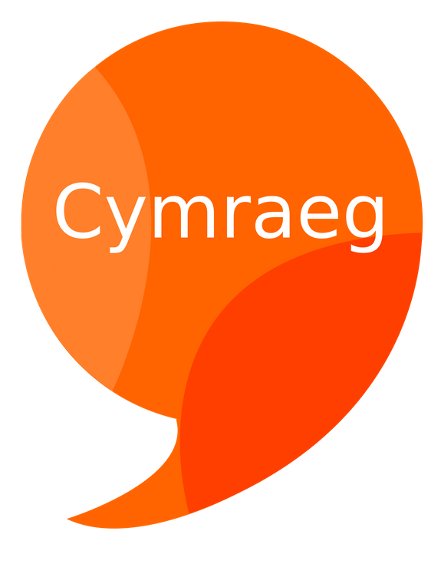
Mae’r brand Iaith Gwaith a’r bathodynnau ‘Cymraeg’ yn ffordd rhwydd o hyrwyddo gwasanaeth Cymraeg. Os oes rhywun yn gwisgo'r bathodyn yma, neu gortyn gwddf gyda'r logo, mae hyn yn dangos bod modd i rywun ddechrau sgwrs yn Gymraeg gyda nhw.

dangos bod modd i rywun ddechrau sgwrs yn Gymraeg gyda nhw.

The Iaith Gwaith brand is an easy way of promoting Welsh services. If someone is wearing this badge, or lanyard with this logo, this shows that they can have a conversation in Welsh.

Gweithgaredd: Dod o hyd i siaradwyr Cymraeg y Coleg
Dewch o hyd i staff yng Ngholeg Gwent sydd yn gwisgo'r cortyn gwddf yma neu fathodyn 'Cymraeg'. Eglurwch beth yw'r dasg a gofynnwch yn garedig wrthynt am eu henw a theitl eu swydd.
Cofnodwch y wybodaeth yn y tabl isod.
Activity: Find the Welsh speaking staff at the College.
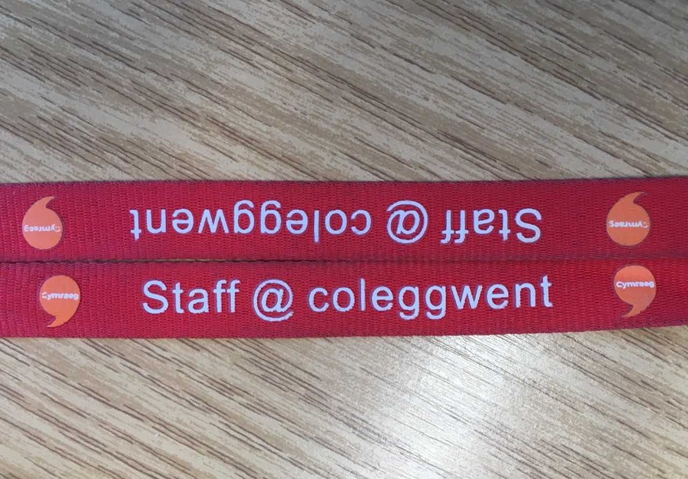
Find Coleg Gwent staff who are wearing this lanyard or the 'Cymraeg' badge. Tell them about your task and kindly ask for their name and job title. Record the information in the table below.

 | Enw / Name | Rôl / Role
1
2
3
4
5
6
7

Welsh-speaking students at Coleg Gwent also wear 'Cymraeg' badges and lanyards designed especially for Coleg Gwent students.

Do you, or any of your peers wear the 'Cymraeg' lanyard?

If wish to let other Welsh speakers know that you're happy to converse with them in Welsh, ask for a 'Cymraeg' lanyard at Learner Services Desk.

Remember that you have language rights at Coleg Gwent!

Section Eight – Current Opportunities for an Entrepreneur (AC 7.1, 7.2)
IC
CTPS
PO
Activity One
Using at least 3 sources such as the internet or newspapers/magazines/journals, and identify at least 4 current issues s within the sector, which could lead to an entrepreneurial opportunity
List below 4 opportunities that you have found:
News Stories | What Opportunity could this present for an Entrepreneur? | Sources used.  E.g. Internet, newspapers.
Covid Lockdown | People are amazingly adaptive and responsive to change. Existing SME’s are responding to the new reality of what they can and can’t do during this period and thinking of different ways of utilising the skills and resources they have to maintain productivity. Take the example of Gtech and Dyson. Vacuum cleaners aren’t rolling off their production lines this week, but rather ventilators to equip our NHS with the kit they need. Hotels have had to close their doors to paying guests, but are open to self-isolating key workers. | https://www1.chester.ac.uk/business-growth/working-us/top-tips/entrepreneurship-covid-19-lockdown
Section Nine – Innovative Proposal
IC
CTPS
PO
DL
Activity One
Work as an individual or as part of a team (consisting of 3-6 members), to develop a proposal of at least 350 words for an innovative proposal to one of the opportunities that has been identified by either yourself or a member of the team. You might want to consider the following approach:
1) The product or service will meet a need.
2) The opportunity will work in your location
3) The resources you need
4) You can provide the product or service at the right price according to the market
5) Is the timing right
As an individual/team, plan and organise a pitch and an information leaflet/guide/poster to give information to your peers/employers on the opportunity and how you would turn this into an entrepreneurial activity, lasting no longer than 10 minutes in length.

Section Ten - Time Management (AC 9.1, 9.2)
N
CTPS
Activity One
When thinking about your Career, you need to be able to plan your time, to ensure you arrive at work on time.
You have been offered the opportunity of doing some work experience for a company in Newport. You will be required to work Monday to Friday for two weeks. The start time is 9:00a.m. but you should get there 10 minutes early.
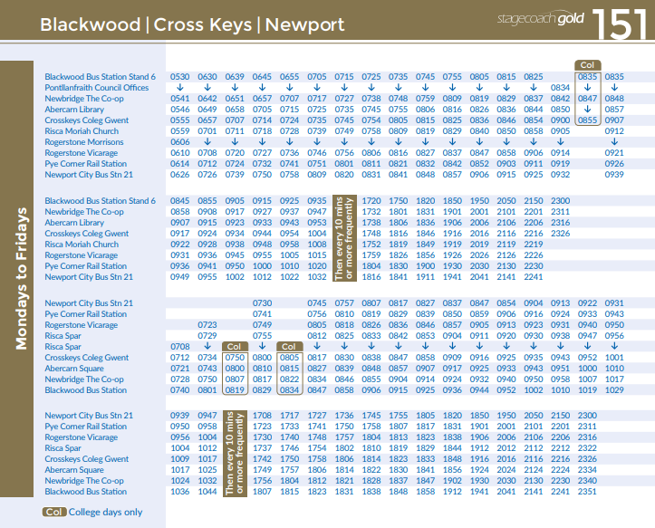
You have decided to travel to and from this placement by bus. It takes 5 minutes to walk from your home to the bus stop outside of Crosskeys Coleg Gwent and 10 minutes to walk from Newport City Bus Station to your placement.

- What time do you suggest that you would need to leave home in the morning?

- What time should you expect to arrive at the placement?

For the first week you decide to buy the ticket on the bus each day. This is the information about ticket prices.
Cash Fares

Adult fare Child fare
(age 5 – 15)

Single ticket £4.10 £2.70
Day ticket* £8.30 £6.30

*Valid for unlimited use for 1 day on all bus routes

c) Which ticket should you ask for on the bus each day?
During the first week, you decide to investigate whether there are cheaper and more convenient ways to pay for bus travel for the following week.
You see this information about season tickets and the My travel pass.
Regional travel card

Valid on all buses, 7 days a week

1 week £37.30
4 weeks £ 140.30
52 weeks £ 830. 90

My travel pass

Apply online for a My travel pass.
33% discount on any bus route for 16-21 year olds.

d) Calculate the cost of travel for the second week using both the regional travel card and my travel pass. How much would you save compared to the first week?

Section Eleven - Produce a Digital Communication on the Importance of the Soft Skills (AC 10.1, 10.2)
DL
PO
Activity One
Work as an individual or as part of a team (consisting of 3-6 members), to produce a digital communication for other students on ‘Why Soft Skills are Important in Today’s Workplace’.
You can use effects such as:
- Blogs
- V blogs
- You Tube Clips

Section Twelve – Evaluation (AC 12.1)
PE
Question | Answer
What Hard Skills have you gained this academic year?

What Soft Skills have you gained from this academic year?

How did you work with others during the academic year?

Describe how your personal confidence has changed as a result of your studies this year?

Personal feelings and opinions about the completion of your studies.

For Tutor Use Only
Tutor feedback to learner on completing the unit

Tutor assessment statement
I confirm that I have assessed the work within this booklet and the learner has achieved all criteria and outcomes at the appropriate level, and the unit may be awarded to the learner, subject to verification.

Tutor signature___________________________________________ Date_____________

